CPTED Evaluation
The location that I am conducting a CPTED evaluation is Misawa’s North Area Shoppette
CPTED Strategy | This location is successful using this strategy in the following ways… | This location needs the following improvements in this strategy…
Natural Surveillance | 1. Very well lit  2. There are big windows in the front of the store  3.  4. | 1. Store is inside of a building (mini-mall)  2. The windows are covered with flyers, remove the flyers and put them on a bulletin board  3. Gas pumps are behind the store with no immediate access inside  4. ATM access is on the outside in a small “covering”, normally with a blinking light
Access Management | 1. There are plenty of exit signs in the store and throughout the building  2.There are 2 doors at the entrance/exits (almost like a sally port)  3.  4. | 1. No fence. Gas pump is next to wooded area, behind the store  2. It has 2 entries, one at each end of the building; one entry should be closed/locked after a certain time at night.  3.  4.
Territorial Reinforcement | 1.  2.  3.  4. | 1. Parking lot is shared with school and housing. Should be one main parking lot dedicated for customers only.  2. Cars have been parked there for quite some time. Any vehicles left unattended should be towed.  3.  4.
Physical Maintenance | 1.Area is always kept clean and free of any debris  2.Any broken items are fixed right away  3.ATM is hidden by tall shrubs  4. | 1. ATM on the outside should be relocated to the inside. Or the lighting should be brighter in the covering.  2.Also shrubs hiding ATM should be cut short  3.  4.
Order Maintenance | 1. Surveillance cameras are used on the inside of the store.  2.  3.  4. | 1. Need cameras on the outside of the building, esp. in the back with the gas pumps.  2. Need more signs stating to business only. Parking for customers only, no trespassing.  3. Cars have been parked there for quite some time. Any vehicles left unattended should be towed.  4.
Activity Support | 1.  2.  3.  4. | 1. The store is off of the street backed up to a wooded area, needs to be closer to the street.  2.  3.  4.

Please include ONE photo showing where the location is adhering to CPTED strategies and ONE photo showing where the location needs improvement with CPTED strategies. (Photos can be taken with a camera or phone. It’s easiest to copy and paste the photo in the table below. Try to get as clear a photo as possible for this assignment).
GOOD example of CPTED strategies | Area where location needs IMPROVEMENT using CPTED strategies
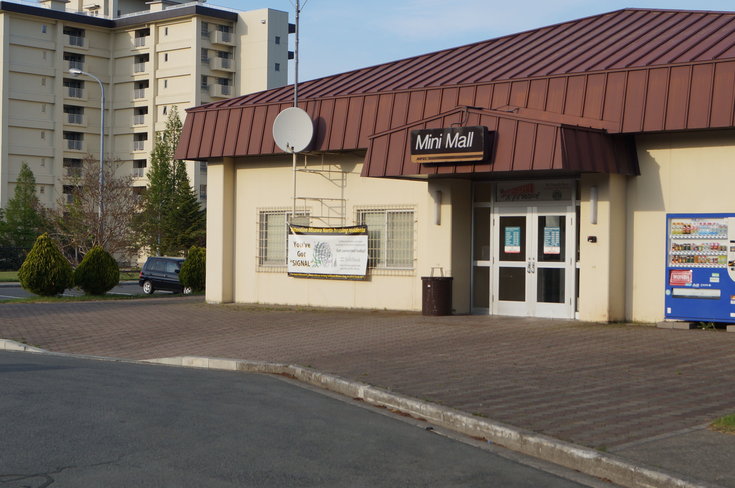ace photo here | 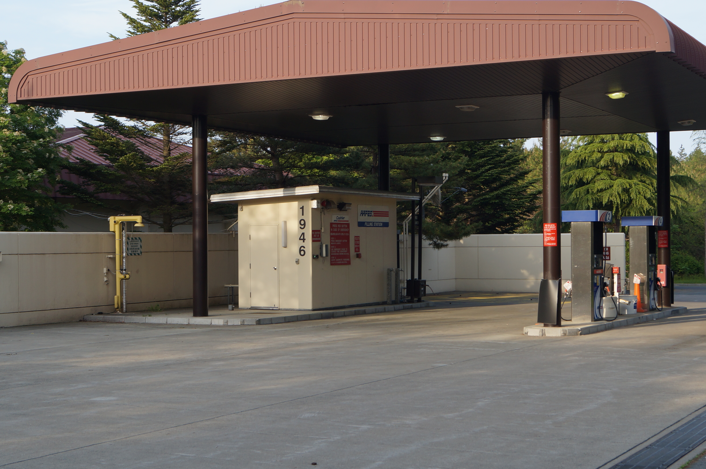

Name__________________________________________ Date______________________________________________

